You Shall Not Commit Adultery

Hebrews 13:4 Marriage should be honored by all, and the marriage bed kept pure, for God will judge the adulterer and all the sexually Immoral.

This commandment requires everyone not only to live chastely in thought, word, and deed in his particular situation (that is, especially in the estate of marriage), but also to love and cherish the wife or husband whom God has given. For marital chastity it is above all things essential that husband and wife live together in love and harmony, cherishing each other whole-heartedly and with perfect fidelity. This is one of the chief ways to make chastity attractive and desirable. Under such conditions chastity
always follows spontaneously without any command. Large Catechism, 219
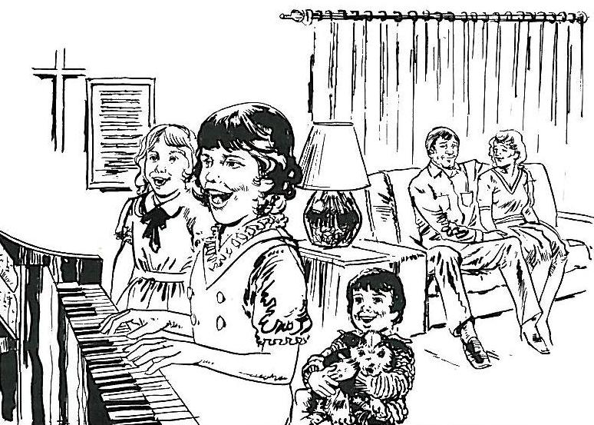

Read Matthew 19:5-6
1. What is God's definition of marriage?

Read Romans 7:2
2. How long does it last?

Read Genesis 2:18,24; Genesis 1:27-28
3. What blessings does God promise in marriage?
1)
2)
3)
4. How does the artist portray the positive aspects of Christian marriage?

Read Genesis 39:6-18
1. What job had Potiphar given to Joseph?
2. Describe Joseph. What did Potiphar's wife tell him to do?
3. How did Joseph respond to her command?
4. When Potiphar's wife tried again, what did Joseph do?
5. Against whom would Joseph have sinned if he had slept with the woman?
6. What is adultery?

1 Corinthians 6:18-20 Keep far away from sexual sins. All the other sins a person commits are outside his body. But sexual sins are sins against one's own body. Don't you know that your bodies are temples of the Holy Spirit? The Spirit is in you. You have received him from God. You do not belong to yourselves. Christ has paid the price for you. So use your bodies in a way that honors God. (NIrV)

